Module Name: SauceDemo E-Commerce – Functional & Test Execution Cases
Test Case ID: Pr-8
Webpage URL: https://www.saucedemo.com
• Scenario ID: 1
Scenario: Open SauceDemo login
Test Steps:
1. Open SauceDemo login
2. Input: Website Link
3. Expected Result: Displayed Login page
4. Actual Result: Login page displayed
Status:
PASS
Remarks:
Login page opened successfully.
Screenshots:
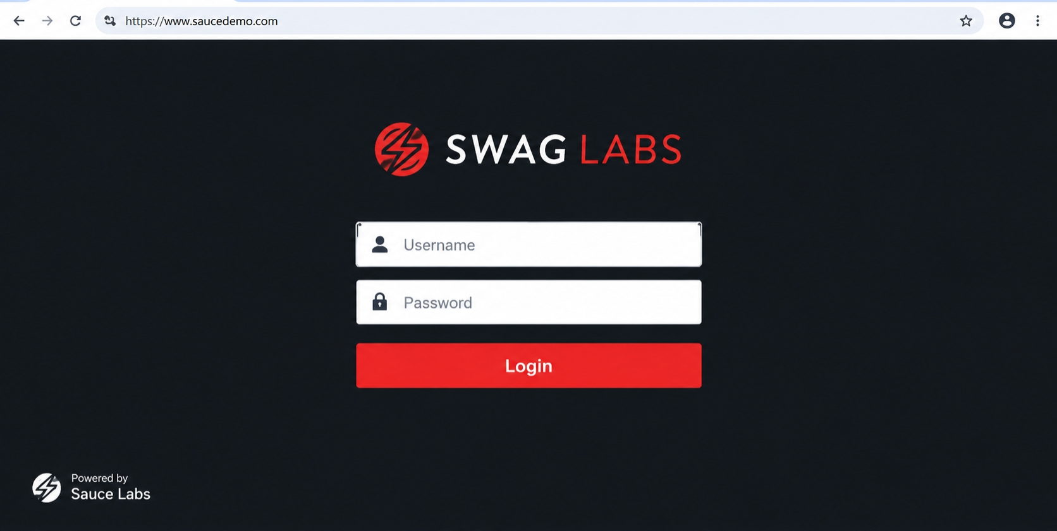
• Scenario ID: 2
Scenario: Enter valid username
Test Steps:
1. Enter valid username
2. Input: standard_user
3. Expected Result: Username should be accepted
4. Actual Result: Username accepted
Status:
PASS
Remarks:
Valid username accepted.
Screenshots:

• Scenario ID: 3
Scenario: Enter valid password
Test Steps:
1. Enter valid password
2. Input: secret_sauce
3. Expected Result: Password should be accepted
4. Actual Result: Password accepted
Status:
PASS
Remarks:
Valid password accepted.
Screenshots:
• Scenario ID: 4
Scenario: Click Login button
Test Steps:
1. Click Login button
2. Input: Valid credentials
3. Expected Result: User should be successfully logged / Products page should be displayed
4. Actual Result: Products page opened successfully
Status:
PASS
Remarks:
Login successful and Products page displayed.
Screenshots:
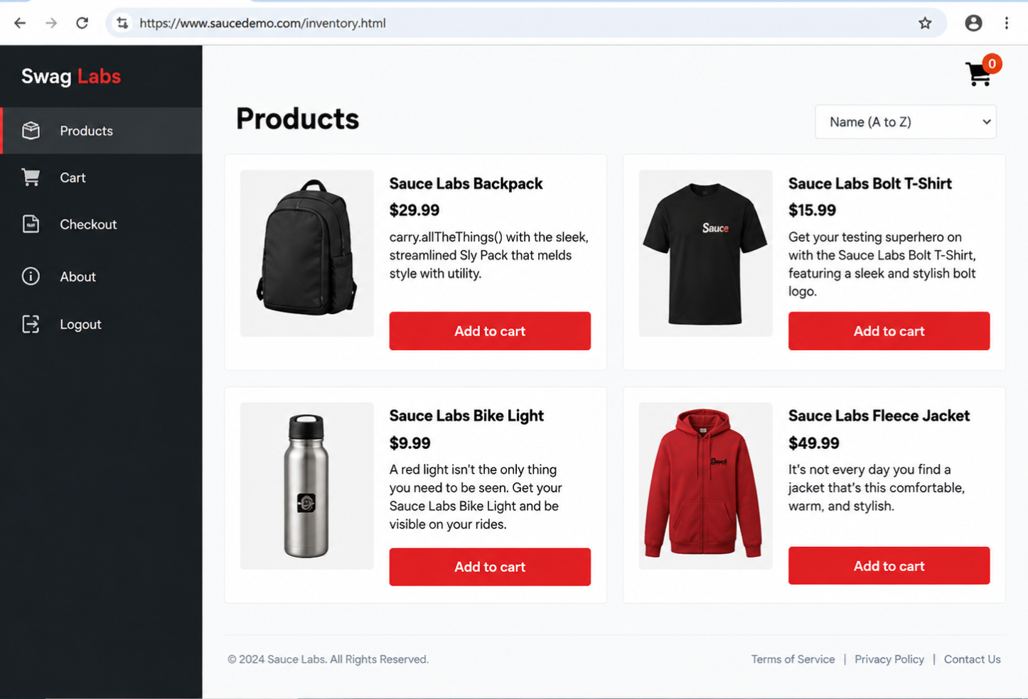

• Scenario ID: 5
Scenario: Enter invalid credentials
Test Steps:
1. Enter invalid credentials
2. Input: Standard_user / wrong password
3. Expected Result: Appropriate error message should be displayed
4. Actual Result: Error message displayed for wrong password
Status:
PASS
Remarks:
Invalid credentials handled with error message.
Screenshots:
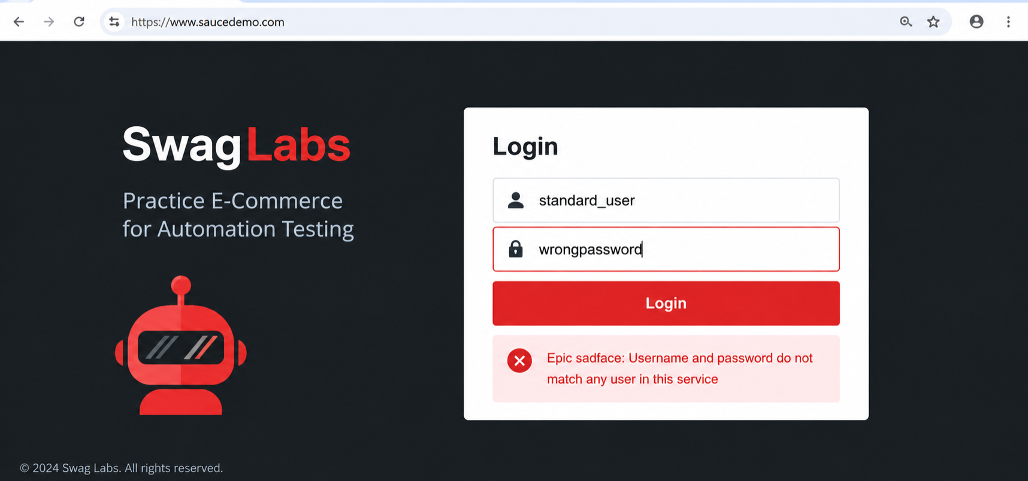
• Scenario ID: 6
Scenario: Select a product
Test Steps:
1. Select a product
2. Input: Sauce Labs Backpack
3. Expected Result: Product details should be displayed
4. Actual Result: Shows product details
Status:
PASS
Remarks:
Product details displayed successfully.
Screenshots:
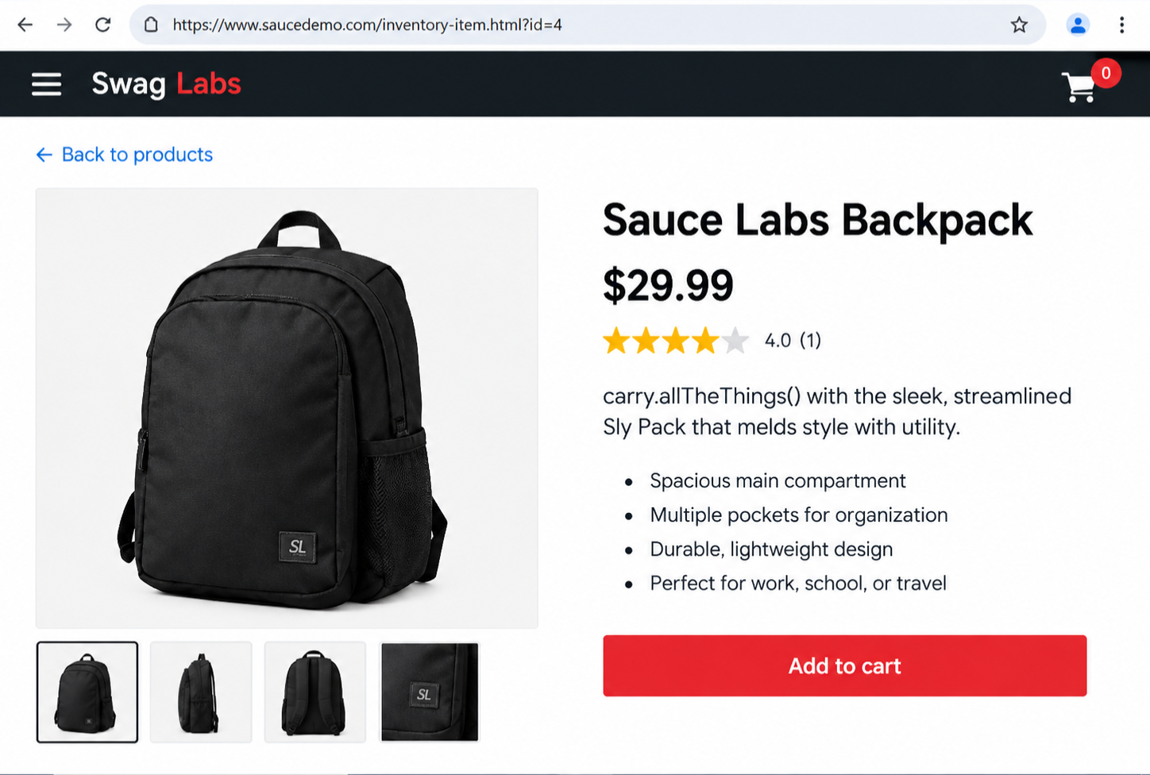

• Scenario ID: 7
Scenario: Add product to cart
Test Steps:
1. Add product to cart
2. Input: Sauce Labs Backpack
3. Expected Result: Product should be added to cart
4. Actual Result: Product added to cart
Status:
PASS
Remarks:
Product added to cart successfully.
Screenshots:
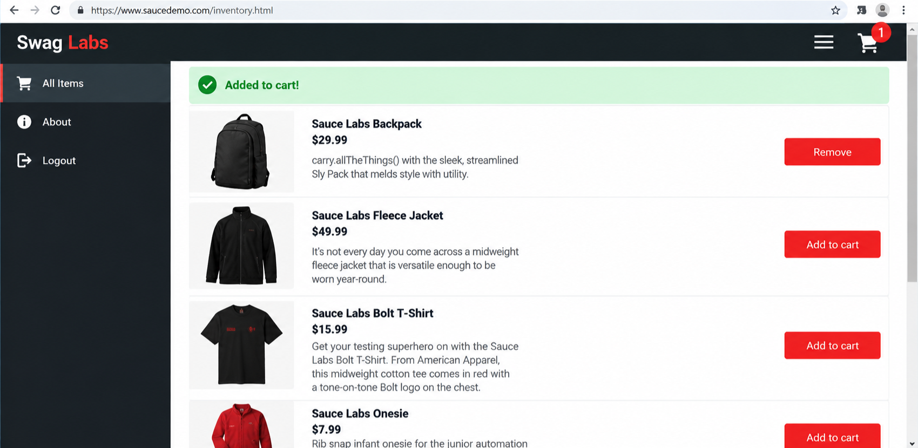
• Scenario ID: 8
Scenario: Open shopping cart
Test Steps:
1. Open shopping cart
2. Input: Click Cart
3. Expected Result: Cart should display selected product
4. Actual Result: Backpack displayed with quantity
Status:
PASS
Remarks:
Selected product displayed in cart.
Screenshots:
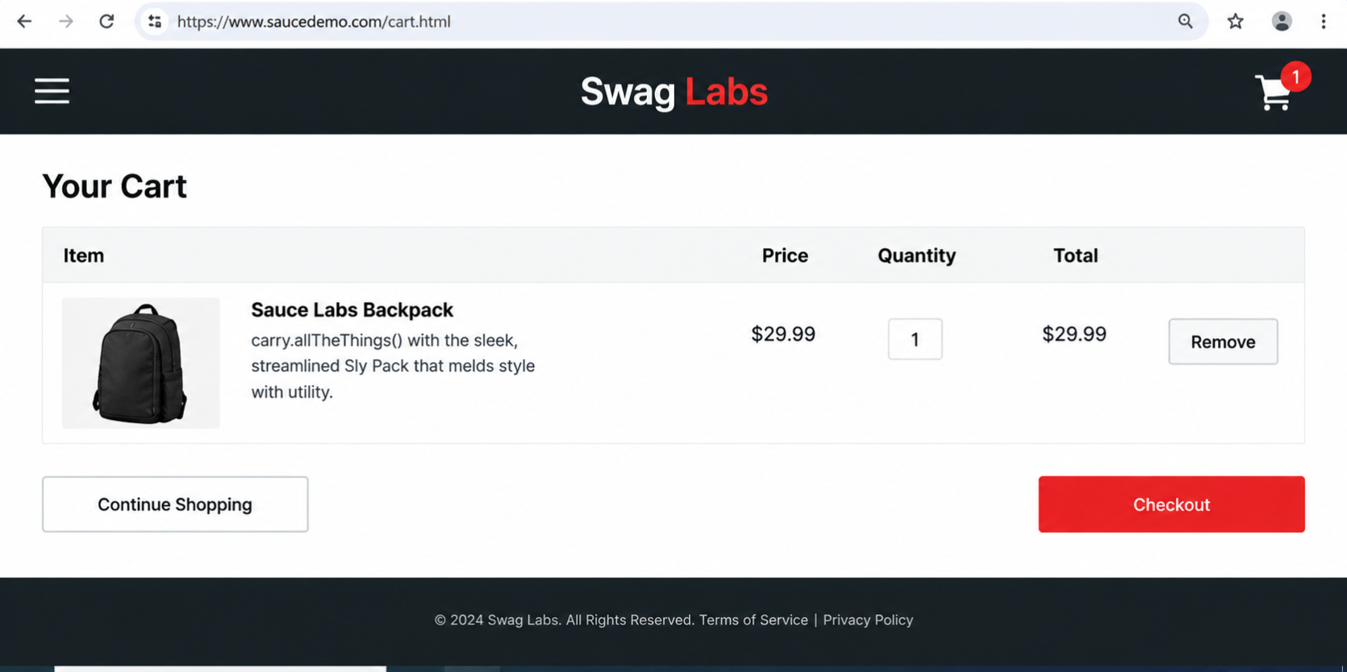

• Scenario ID: 9
Scenario: Open Checkout
Test Steps:
1. Open Checkout
2. Input: Click Checkout
3. Expected Result: Checkout information form should be displayed
4. Actual Result: Checkout form displayed
Status:
PASS
Remarks:
Checkout information form displayed.
Screenshots:
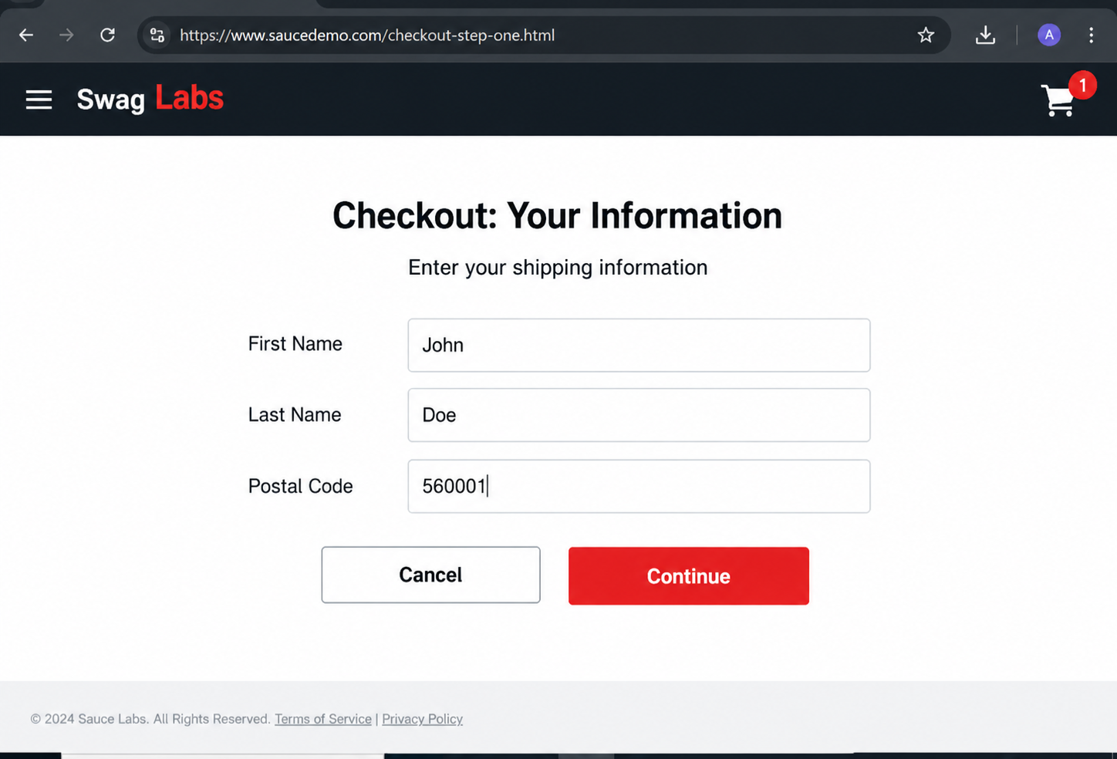
• Scenario ID: 10
Scenario: Test checkout
Test Steps:
1. Test checkout
2. Input: Leave First Name blank
3. Expected Result: Validation error should be displayed
4. Actual Result: Checkout form displayed
Status:
PASS
Remarks:
Checkout overview displayed successfully.
Screenshots:
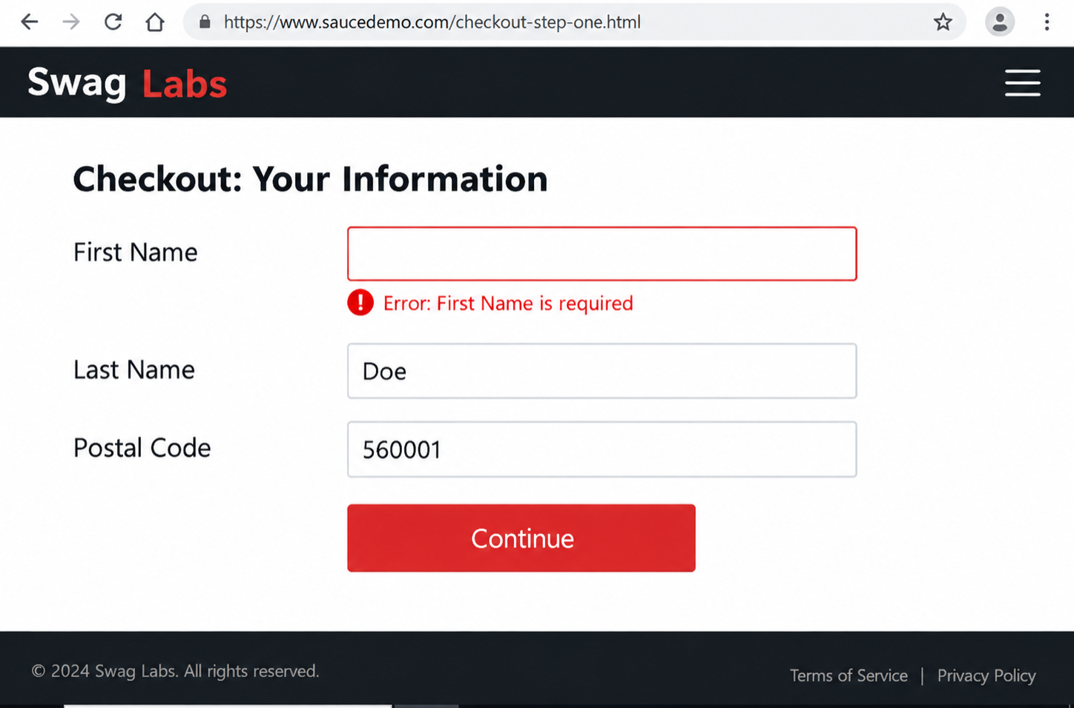

• Scenario ID: 11
Scenario: Enter valid checkout info
Test Steps:
1. Enter valid checkout info
2. Input: John Doe / 560001
3. Expected Result: User should proceed to checkout
4. Actual Result: Checkout overview displayed
Status:
PASS
Remarks:
Order confirmation displayed successfully.
Screenshots:
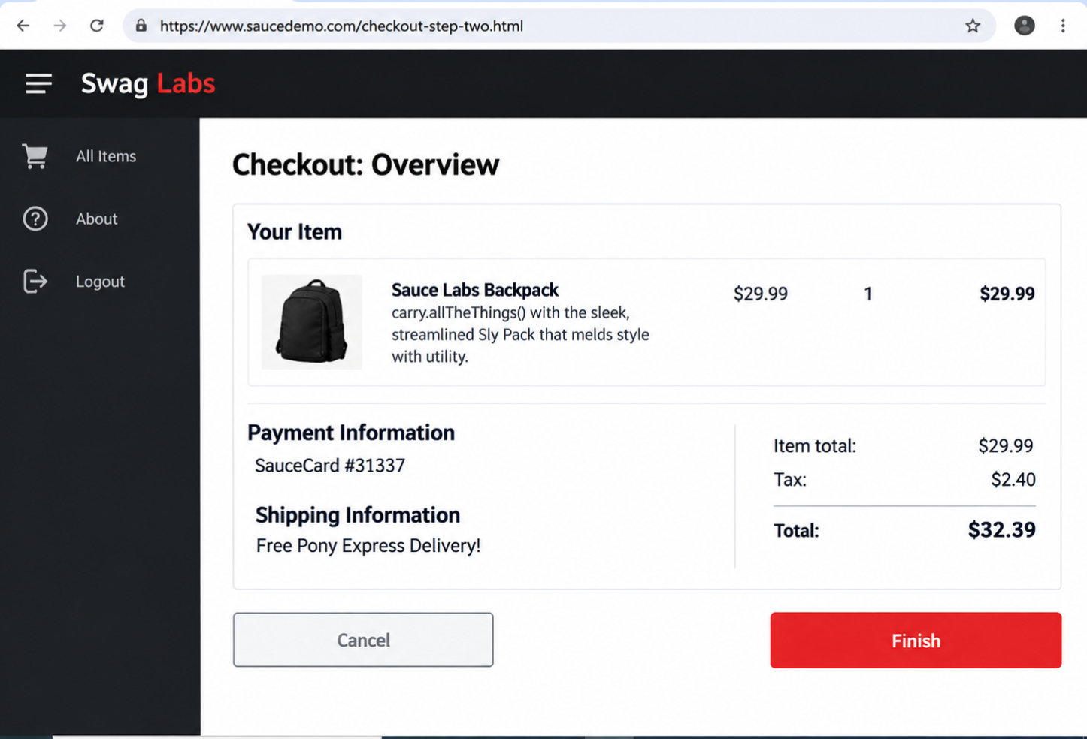
• Scenario ID: 12
Scenario: Finish order
Test Steps:
1. Finish order
2. Input: Click Finish
3. Expected Result: Order confirmation should be displayed
4. Actual Result: “Thank you for your order” displayed
Status:
PASS
Remarks:
Order completed successfully.
Screenshots:
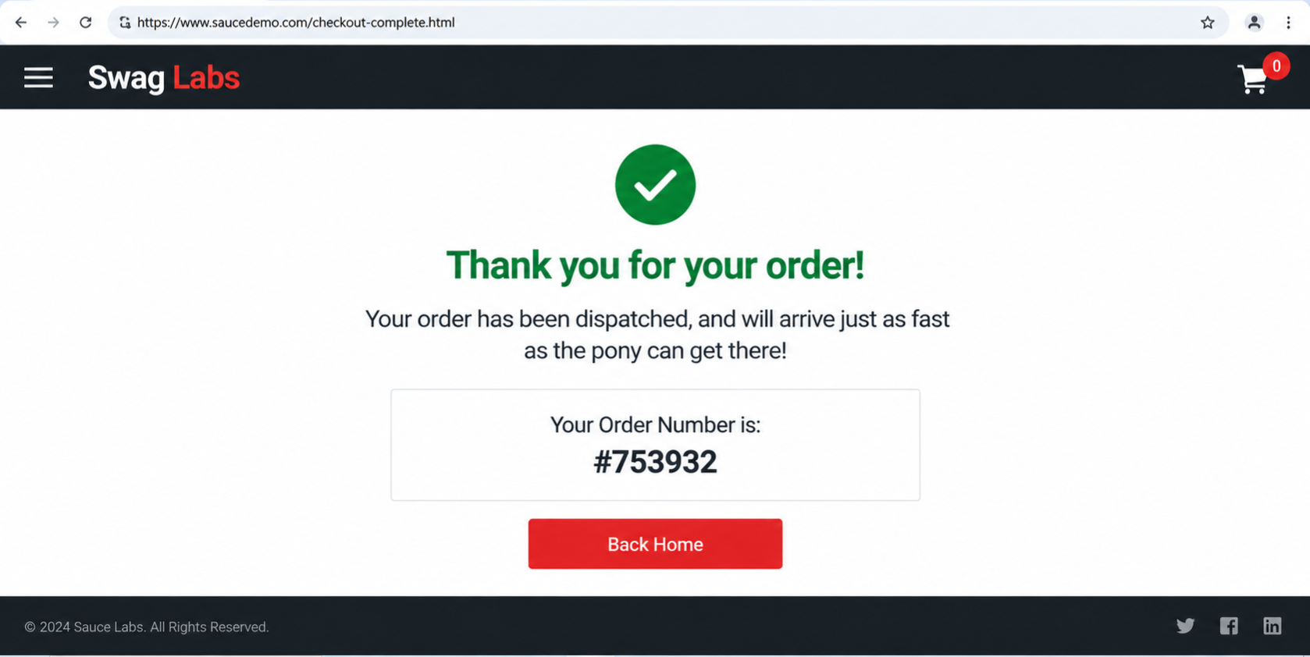
• Execution Summary
Scenario: TestLink test execution evidence
Test Steps:
1. TestLink execution dashboard reviewed
2. Execution status screenshot included below
Screenshots:
